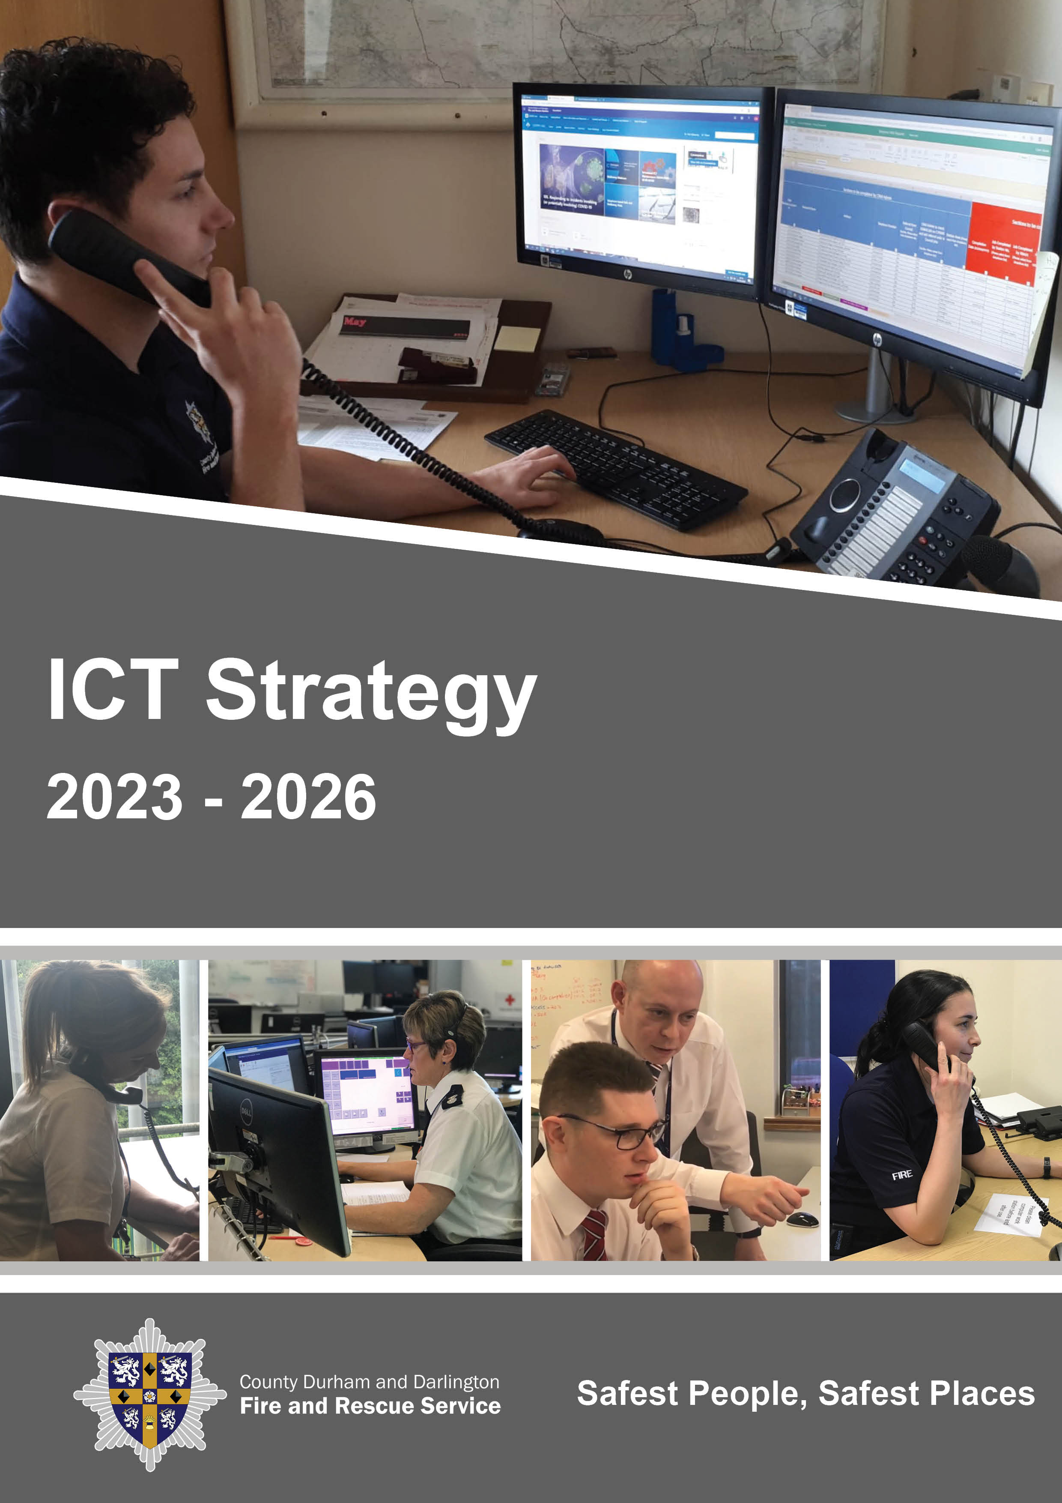

ICT Strategy 2023 -2026

Foreword

County Durham and Darlington Fire and Rescue Service’s (CDDFRS) vision is to have the Safest People, Safest Places. Our core strength in achieving this is through our people who are proud to work for an organisation connected closely with its communities and who are genuinely committed to changing and saving people’s lives.
The Service’s strategic priorities are detailed in our Community Risk Management Plan (CRMP) which explains our vision “Safest People, Safest Places” and how we plan to achieve this. In order to assess all foreseeable fire and rescue-related risks that could affect the communities of County Durham and Darlington we have in place a methodology for assessing the potential of these risks to cause harm to our communities which is set out within our Community Risk Profile (CRP). These risks are then analysed by the Divisional Management Teams to assist them when developing their own station-based profiles.
This ICT Strategy forms part of a suite of documents which support the delivery of the CRMP. It covers the areas of Service Desk and Support, Infrastructure Management, Information Security, Local and Wide Area Networks, Mobile Data, Server Hardware, Telephony / Radio / Alerter Support, Provision and Support for a wide range of desktop, laptop and tablet hardware, Software Application Deployment and Business Continuity / Disaster Recovery Management.
The Government’s fire reform agenda sets a clear direction of travel to ensure fire and rescue services are efficient, accountable, transparent and reflective of the diverse communities they serve. This is underpinned by His Majesty’s Inspectorate of Constabulary and Fire and Rescue Services (HMICFRS) regime and the Fire and Rescue National Framework for England that sets out the overall strategic direction for fire and rescue authorities.
We expect the Authority to continue to face a very challenging financial climate going forward with great uncertainty as to future Government funding. This is exacerbated by restrictions on the amount of income we can raise through council tax and predictions of significant pressures on spending. Nevertheless, since the Authority has invested significantly to produce a modern estate, it is important that this investment is not allowed to deteriorate, and this strategy seeks to secure the long-term sustainability through effective and efficient ICT management.

Where are we now?

In recent years despite the challenging reductions in funding from central government, investment in ICT within the Service has remained strong. Key improvements have been made in resilient infrastructure, software and security systems to protect Service resources and data.

In particular, the move to cloud-based technologies has not only improved ways of working for all personnel but significantly improved resilience and allowed access to flexible working for all staff. The Service has increased awareness of the threats to information assets across the workforce and has a rigorous audit regime in place to ensure standards across all aspects of ICT are continually being challenged.
Since our last ICT Strategy was published, we have implemented the following ICT improvements:

- The ICT infrastructure which was previously accommodated in key buildings within our estates, such as Fire Service Headquarters, has been successfully transferred to third party hosted data centres. This has substantially improved ICT infrastructure resilience and reduced ICT’s reliance upon Service buildings. Consequently, our carbon footprint and utility costs have been significantly reduced, specifically in HQ.
- All user desktop environments have been refreshed with current technology.
- Initial staff training on necessary security standards has been undertaken and is now part of their annual training programme.
- Ways of working have been modernised through cloud-based investment, improving accessibility and availability remotely.

- The data environment has been cleansed and restructured which maximises the Service’s data assets.
- Following our cloud-based investments, software and hardware provision has been reviewed to rationalise licencing, reduce hardware spend.
- Resilience has also been revised and improved with the new cloud-based disaster recovery arrangements.
- Remote working to the desktop environment has been improved to allow a more seamless transition for end users.
- A Bring Your Own Device (BYOD) programme has been rolled out and is available to all end-users within the Service.

A 10-year capital replacement programme exists to ensure major investments are managed over the medium term. This also ensures that the whole ICT estate can be managed in accordance with emerging technologies to fully exploit current capabilities.
Investment in ICT requires constant review. There is a balance between achieving value for money from the lifetime of an asset to enabling the workforce to make use of ICT and current capabilities to deliver enhanced services or achieve improved productivity.
The whole life cycle of the asset is be considered at the procurement stage to deliver value for money from the most economically advantageous tender.

Key Drivers

The key drivers which have set the direction of the ICT Strategy are:

- Government, Sector, and Industry best practice for maintaining a secure infrastructure and protecting data assets (National Cyber Security Centre (NCSC) – Cyber Assessment Framework and National Fire Chiefs Council (NFCC) Data Management Fire Standard).

- National Infrastructure Programmes such as the cessation of the Public Switched Telephone Network (PSTN)

- HMICFRS – Ensure we address areas of improvement relating to efficiency, effectiveness and people from our inspection and aim to become an ‘outstanding’ fire and rescue service.

- Introduction of flexible working to the organisation which has changed how the Service use technology.

- Ensuring the ICT Infrastructure is resilient to the impact of major events including widespread power outages and natural disasters such as flooding.

- Actively seeking and supporting collaboration opportunities with key partners in the interests of efficiency, effectiveness or reducing risk to our communities and staff.

- Collaboration with other Fire and Rescue Services to deliver technologies connected to Critical National Infrastructure including the modernisation of the Command and Control system and mobilisation technologies.

- Balancing the budget within the Medium-Term Financial Plan.

- Our values: Professional, Innovative and Effective describes the service our customers should expect to receive.

- A statutory duty to collaborate with Police and Ambulance as stated in the Policing and Crime Act 2017

Our Values, Behaviours and Ethics

The Service’s core values, behaviours and ethics are integral to the People Strategy as they define the principles that guide our Service’s internal culture as well as its relationships with external communities, stakeholders and partners. Our core values, and behaviours and ethics are embedded across everything we do, in the areas of performance, promotion and talent management.
Our Values are Professional, Innovative and Effective (PIE). PIE represents our values and describes the service our customers should expect. This element of ‘being the best’ is the external key message around the service we provide.

The 4 Cs communicates the behaviours we expect all our people to display at work. Delivery of the 4 Cs across the service will lead to an organisation which displays the PIE values and fulfils the organisation aim of ‘being the best’.


How We Approach Challenges
Our people should approach challenged with flexibility, enthusiasm, motivation, passion, determination & resilience.

How We Conduct Ourselves
Our people should conduct themselves in an honest, trustworthy, reliable, accountable, consistent and respectful manner.

How We Collaborate
Our people should be approachable, supportive, encouraging, inclusive and show that they value their own development and the development of others when collaborating and working with others.

How We Drive Change Across the Organisation to Make a Difference
Our people should drive change by being creative, resourceful, courageous, original, clear and focused.

Our ethical principles are:
- Putting our communities first – we put the interests of the public, the community, and the service users first.

- Integrity – we act with integrity including being open, honest and consistent in everything we do.

- Dignity and Respect – we treat people with dignity and respect, making decisions objectively based on evidence, without discrimination or bias.

- Leadership – we are all positive role models, always demonstrating flexible and resilient leadership.

- Equality, diversity and inclusion (EDI) – we continually recognise and promote the value of EDI, both within the FRS and the wider communities in which we serve. We stand against all forms of discrimination, create equal opportunities, promote quality, foster good relations and celebrate difference.

Where do we want to be?

We want to be able to clearly demonstrate that we are aiming to ‘be the best’ fire and rescue service by positively embracing new technology.

By striving to exploit best practice within and outside of the fire sector we will achieve sustained service development and improvement that translates into better service for our communities.

Our ICT Strategy sets out a framework to ensure the Service maintains pace with a rapidly changing environment. The strategy details an ambitious three-year programme, but it should keep CDDFRS at the forefront of technological change.

The focus is on building upon our strong foundations of accessing cloud-based technology,
driving efficiency through investing in new technologies and further hardening the
organisations security position.

Key Principles

To support the delivery of this ICT strategy we have adopted underpinning principles that we will apply to our improvement objectives.
These are as follows:

- We will give our staff the most efficient and effective technological hardware and software to allow our staff to perform to their very best and help us achieve our aim of being the best fire and rescue service in the UK.

- We understand the importance of investing in staff awareness in relation to infrastructure, systems and data security and believe that this will benefit employees both inside and outside of the workplace.

- We trust our people to make decisions and will give them the skills, knowledge and access to appropriate information in order to do this effectively.

- We will ensure there is a clear route for staff to highlight new improvement and innovation opportunities to our Service.

- We will embrace a culture of continuous improvement leading to continuous organisational improvement that translates into better service for the public.

- We understand the importance of engaging staff in decisions and will listen and involve our people in improving the technologies that we deploy and therefore improve our service.

- We trust our staff to uphold the highest standards of personal and professional conduct including openness, honesty and integrity.

To achieve this, the ICT Strategy has five key improvement objectives (KIO) outlined below. Each objective will have an action plan which will be monitored regularly and refreshed as progress is made.

How do we get there?

Security

Through the application of the NCSC Cyber Assessment Framework (CAF) the ICT Section will assess and identify areas for improvement against the NFCC Data Management Standards. The ICT Strategy is committed to following the principles of the ISO27001 framework and the National Protective Security Agency (NPSA).
Members of the ICT Section will actively engage with national, regional and local cyber security forums and working groups to ensure best practice and to stay apprised of emerging risks to our organisation and our partners.
To ensure the security of all Service ICT systems the ICT Section is mandated to conduct a CHECK scheme accredited IT Health Check on an annual basis. This provides a high quality and well-regarded penetration testing service for Critical National Infrastructure (CNI) systems and networks. Any vulnerabilities discovered during the IT Health Check will be risk assessed, rectified and re-tested as required.
The ICT Section in collaboration with the Service’s Information Asset Owners will agree the processes and procedures to be adopted to ensure the security and effective management of all Service systems and the information contained within. During the lifecycle of this ICT strategy the aim of the ICT Section is to align the Service’s security methods to recognised IT Industry Standards such as the Zero-Trust Framework and Principle of Least Privilege concept.
The ICT Section are continually apprised of the changing security landscape and will provide regular advisories and bulletins via the Service’s communication channels with the aim of protecting all personnel and third parties, where applicable, whether they are at home or at work.

Communications

Although transition to ESN (Emergency Services Network) will be mandatory and will need to be undertaken before decommissioning of Airwave, the Home Office has taken the decision to suspend the delivery of the ESN project until mid-2025, which means transition to ESN will not take place until 2027/2028.
Following the decision to suspend rollout of ESN, the ICT Section will explore emerging technologies, such as 4G/5G, to provide wireless communications to emergency response vehicles which will prepare the Service for transition to ESN when it is delivered.
The ICT Team will support the Service to transition the Command-and-Control room systems from premises based to a fully hosted cloud solution within the period of this strategy.
Sharing infrastructure with other fire and rescue services will provide better resilience and greater collaborative opportunities.
The ICT section will upgrade the internal on-premises Mitel telephony system to incorporate additional functionality and resilience using modern cloud technologies. This will support the transition to a fully hosted command and control system and remove the reliance on PSTN and ISDN circuits which are due to be retired by BT in 2025.
The ICT section will integrate the Service’s telephony system into Microsoft Teams to provide a unified communications solution which will support hybrid working by providing a softphone which can be used at any location on any device.
The emphasis on a unified communications solution is to transition to a departmental approach to call handling with support for flexible working. The ICT section will provide guidance and support to ensure the solution is utilised to its full potential and with this approach remove the reliance upon a single individual redirecting their calls when they are working from another location or not available.

Digital Transformation
To assist with Service’s digital transformation programme the ICT Section will in conjunction with Departmental Managers, facilitate the transformation of inefficient processes to improve data quality and security. The ICT Section will develop modern applications to allow end-users to capture, process information and visualise it through dashboards and Power BI reports.
System integration is key to the Service’s digital transformation programme as this allows all data, collected in whichever system, to be readily available to all end-users within the organisation and facilitates the secure transfer of information between systems.
Access to timely and current information is crucial to Emergency Response teams to enable them to make informed decisions on the frontline. Collaboration with our emergency service partners and system suppliers relies on sharing this data, the ICT Section will therefore engage with internal and external teams to support the secure delivery of information to different software and hardware platforms.
The ICT Section will work closely with procurement processes where system technical requirements are involved to ensure that new systems are compatible with the Service’s current infrastructure and ideally can be integrated.
We will continue to invest in the Service’s Microsoft enterprise agreement to ensure that we get the full value out the products available in the Office 365 suite. The ICT Section will assess current applications to determine if in-house development and implementation with the Microsoft Power Platform is the most cost-effective solution.

Infrastructure

Following the transition of the core ICT infrastructure to a managed hybrid cloud environment the ICT Section will conduct a review and redesign of the server room at HQ to further reduce power and cooling consumption which will provide cost reductions and improve the Service’s carbon footprint.
The ICT Section will upgrade the network hardware at all sites to increase security, simplify management and introduce modern communication technologies. They will also explore software defined networking solutions to increase resilience of the Service’s infrastructure and remove the reliance on a single internet service provider.

Business Continuity (BC)

ICT’s business continuity plan is designed to support individual section plans during events which impact business as usual activities. ICT will assist stakeholders to continually review their sections plans to provide advice, resilience, and alternative ways of working where it is necessary to invoke plans.
In the case of a cyber security event, the ICT Section has developed a Cyber Security Incident Response Plan (CSIRP). ICT are committed to testing this plan annually to identify strengths and weaknesses in the service’s BC planning. This plan will be reviewed and updated by the ICT Section at least annually or where internal processes, legislation, and external guidance changes.

Governance and Measuring Progress

We will monitor progress of this strategy in the following ways:

Role of the Fire Authority and Service Leadership Team (SLT)
Both Members of the Fire Authority and SLT believe in this strategy and that it will help to deliver the Service’s vision in respect of its people. Leading by example, our Members and SLT will set the standard for what is expected of all staff in enabling this strategy to be delivered by 2026.

Role of our Staff
This strategy will only be successful if all staff within CDDFRS support it, making the vision of what the Service will look like from an ICT perspective, a reality. In supporting this strategy, employees will not only assist in enabling the actions outlined but they will also demonstrate their support through their behaviours.

Key Performance Indicators (KPI’s)
We have a suite of appropriate Key Performance Indicators to help measure the progress of this strategy.

Culture Survey
Our culture survey will assist us in having insight into the motivations, attitudes and behaviours of our staff. Progress will be measured against key indicators and shared with the workforce.

Reporting Progress
Scrutiny of progress against the strategy will be undertaken by the Performance Board (PB) who will receive regular reports from the Director of Corporate Resources, in their role as strategic lead for ICT.

Measuring Perceptions/ Sense Checking
We will regularly ask for feedback from our staff to inform us of our progress on elements with the ICT Strategy through our engagement sessions, range of leadership forums and through meetings with our representative bodies. Their opinions and suggestions will be used to influence improvement.

Keeping it current
We will provide a progress report to the relevant committees and update the action plan annually to ensure it remains current.


