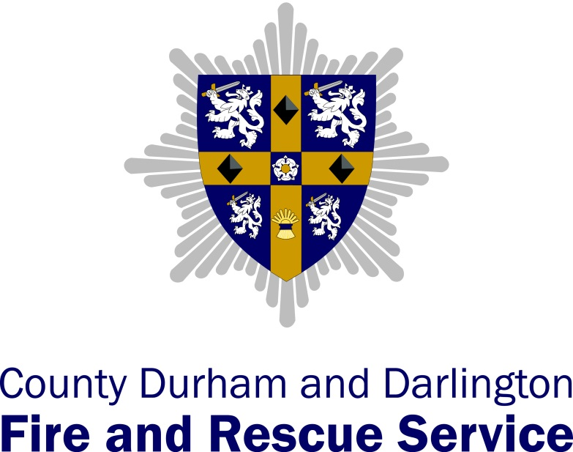

Operational Assessment 2014
Action Plan

Areas to Explore |  | Interpretation |  | Action | Lead Officer | Date for Completion | Progress
Member Training & Development |  | The Member Training & Development Programme could be improved by ensuring:  - The structure & content is relevant and supports the Member Champion roles;  - That individual development needs are captured and inform personal development plans; |  | - Update the Member Training & Development Programme to address the identified areas. | Assistant Chief Fire Officer | April 2015  Revised to June 2015 | Complete  The Member Development Strategy was approved at the June CFA. This takes account of changes to the committee structure and the introduction of the Local Pension Board.  There has been a realignment of officers/members as part of the ‘buddy’ programme and a series of individual induction sessions and group development sessions will now be planned into the coming year.
Communication Marketing & Engagement |  | There is benefit in evaluating our strategic approach to communication, marketing and engagement to provide assurance that the CDDFRS story and our key messages are being delivered and received, both internally and externally.  It was felt that the Service could do more to promote itself and the community outcomes that are being delivered. The team also suggested we should look at whether our communications specialists could add value to our broader transformation strategy. They also asked whether we could make better use of appropriate toolkits and templates to get our messages across.  The team acknowledged the success of local initiatives but encouraged the Service to ensure these are being fed back into the centre and across the districts along with local intelligence so they can inform future plans.  The team also felt that the channels open to staff through which they can suggest improvements for the Service could be reinvigorated. |  | - Improve our approach to communication, marketing and engagement, producing a concise improvement strategy that considers:  - internal/external communication channels  - the role of the communications staff  - our approach to community engagement & consultation  - how we can better market our Service to our partners  - staff suggestion schemes | Head of Corporate Resources | Jan 2015  Publication date TBC | Complete  The Communications and Engagement Strategy was presented to SLT in July 2015 with a number of amendments suggested which have been incorporated into the revised document. The strategy will be published following completion of the strategic review of the Corporate Vision, aims, objectives and values.
Structure and Responsibilities |  | There is an opportunity for the Service to review current portfolios, responsibilities and meeting structures to ensure they are fit for purpose to meet future challenges.  Doing so would help provide clarity about the ownership of the Service Transformation Programme and the development of the strategic plan and IRMP. |  | - Incorporate the findings of the OpA Report into a review of the SLT structure and associated portfolios | Chief Executive | Dec 2014 | COMPLETE  The revised structure was approved by the CFA at the December 2014 meeting.
Corporate Planning & Performance Management |  | A lack of clarity about the existence and awareness of the corporate planning process that is used to drive strategy and policy was observed.  Providing greater clarity about where responsibility for developing and drafting the strategic plan and IRMP would be beneficial. |  | - Review and document the corporate planning process and performance management framework | Head of Corporate Resources | March 2015  Revised Sept 2015 | Complete  The corporate planning timetable was presented to SLT in July 2015.  Responsibility for the development of IRMP has been clarified and this will now be with the Head of Corporate Resources. Following the next round of strategy review any revisions to strategic aims and objectives will be drafted into the next Service publication.
Programme & Project Management |  | The Service should consider using our existing project management framework as a foundation for introducing a more robust approach to the management of major programmes such as the Service Transformation and Estates Improvement Programmes. This would ensure that the use of resources can be more closely monitored and allow SLT to act more responsively to address emerging issues.  Reviewing the effectiveness of our approach to evaluating the outcomes of our initiatives, both at the local and service level, would help managers understand the capacity issues facing the Service and ensure our interventions are having an impact. |  | - Explore the benefits of adopting a more formal Programme Management approach to key projects and review the way we formally evaluate the outcomes of projects and initiatives. | Head of Corporate Resources | October 2014 | COMPLETE  SMT BT now have clear oversight of all major service projects (determined by level of risk & resource impact) and regularly monitor attainment of key milestones and budget variance. Projects are supported by appropriate levels of project control documentation. Reporting by exception is provided to SLT.
Partnership Management |  | Feedback from our partners suggests we could say a great deal more about what we do and our plans for the future. There is an opportunity for CFA Members to use their role within broader partnerships in County Durham and Darlington to promote the work of the Service.  The team felt the Service would benefit from developing a clearer partnership vision to increase opportunities for being commissioned via transformation posts and Area Action Partnerships (AAP).  Providing a clearer vision about how and with whom we want to work in partnership would also help us capitalise the opportunities arising from the emerging public health agenda. For example, the team felt we could use our existing involvement with one urgent care board to promote our fire prevention and community safety activities across the other boards in our area. |  | - Develop a Partnership Strategy that provides staff and partners with a clear partnership vision about how and with whom we want to work in partnership. | Deputy Chief Fire Officer | October 2014  Revised to September 2015 | COMPLETE  The internal audit of the partnership register did not identify any gaps in CDDFRS partnership arrangements with Health. However, national work has commenced through the NJC to run trials with Fire Authorities delivering co-responding and Health prevention initiatives. It is proposed that the expansion of the Services role into the wider health agenda become an IRMP proposal which will be monitored through that process. Therefore, for the purpose of the OpA action plan this action is considered complete.
Succession Planning |  | As responsibility and workload is devolved from the centre to district teams, consideration should be made to the resilience of the central support provided as the numbers of staff in these teams reduce.  The Service should review the approach to retention and succession planning for key central support staff to ensure knowledge and skills are retained. |  | - Extend the succession planning and business continuity arrangements to include Support sections. | Area Manager Org Dev | October 2014 | COMPLETE  The Succession Planning Policy and Procedure was approved at the December meeting of the SMT PS.  The SM OD has commenced work to ensure all personnel are aware of the opportunities it presents in time for the 2015/16 appraisals.
Approach to identifying and analysing risk | Although the Service is rich with data and intelligence, there is an opportunity to review the type and quality of risk information and intelligence available both locally and centrally to identify where gaps lie.  The team felt the Service would benefit from documenting the approach and methodologies we use to identify and analyse community risk so as to provide a consistent narrative that clarifies our approach.  Part of this would be to consider how local station level plans integrate with community risk information, protection activity and training focus. |  |  | - Document the approach and methodologies employed by the Service to identify and assess community risk.  Review the type and quality of risk data available both locally and centrally and produce a strategy to address identified gaps. | Area Manager Ops Support | March 2015 | COMPLETE  Report presented to the July meeting of SLT. Improvement recommendations to be developed via SMTBT.
Home Fire Safety Checks | The team felt the Service could improve its targeting of Home Fire Safety Checks by ensuring that properties located in areas where travel times exceed the 8 minute response time are prioritised as a vulnerable area. |  |  | - Develop the Ward Based Risk Profiles to take account of response times. | Area Manager Ops Delivery | August 2014  Revised to Sept 2014 | COMPLETE  A review of risk ward areas has taken place for the West of the county to take account of travel distances and is being used to inform HFSC targeting. The Information Services Manager has incorporated travel distances as an additional risk layer into the Ward Based Risk Profiles for 2015/16.
Operational Assurance | The existing programme of station based Operational Readiness Audits (OpeRA) could better utilise the expertise of specialist teams such as Health & Safety and Training.  Introducing an element of peer review by involving managers from other districts could provide an additional level of assurance.  Consideration of how the themes of internal audits are prioritised should be made to ensure they are focused on the higher risk areas.  The team felt it important that the outcomes from the active monitoring and incident debrief processes are being effectively communicated to and actioned by both wholetime and retained crews. |  |  | - Refresh the Operational Assurance arrangements to ensure:  - better use of peer review and specialist knowledge  - Themed audits are risk based  - Outcomes are effectively communicated | Area Manager Ops Support | April 2015 | COMPLETE  The annual review of the OPeRA Audit programme was undertaken in the context of the new Service structure and has led to the following changes:  - Audits will be facilitated centrally but will utilise a cross section of district managers and specialists in a peer review capacity, reducing the burden on the central team without adding workload to the DM teams.  - OSHENS will be used to record the outcomes from the audits and also track any actions assigned.  The amended OP/1/22 & OP/2/50 policy were approved by SMTPS prior to the 2015/16 OpeRA audit programme commencing in Sept.  The existing active monitoring and debrief procedures have been reviewed to improve both the process and how the outcomes are shared to inform organisational learning.  The outcomes from operational assurance processes are already used to prioritise the themed audits undertaken by the Service.
Quality Assurance of Training | As more training is devolved, the more critical it becomes for the Service to ensure it has robust quality assurance arrangements in place so it can confidently demonstrate that training objectives are being consistently achieved both centrally and at the local district/station level.  The Service would gain from reviewing how well district level training reflects local risks so that crews are trained and have information on their local risks.  With regard to incident command training, the team felt it wasn’t clear whether there are sufficient opportunities for staff to apply the knowledge and skills they have acquired at realistic training exercises so as to avoid skills decay, particularly in light of the reduction in incidents we attend. |  |  | - Develop an action plan to achieve accreditation to ISO9001:2008 (Quality Management System) for Training.  Review the tactical exercise programme and district level training to ensure they are risk based. | Area Manager Training & Risk | April 2015  Revised March 2016 | COMPLETE  The final accreditation audit took place in service on 31st March 2016. The auditors have indicated we have reached the required standard for ISO 9001:2008. Certification will follow within 6 – 8 weeks.  The Service Tactical Exercise Programme has been reviewed and is now more focussed on being risk based and linking into the LRF (Training and Exercising Working Group/ Risk Advisory Working Group). Responsibility for tactical exercises have now been moved from the Operations to the Training Section.
Fire Control |  |  | The team found that Fire Control staff are keen to become more involved in other areas of the Service’s work and in developing ideas for income streams to mitigate the impact of the savings that the Service has to make. This provides a great opportunity for tapping into another resource and skill set by expanding the role of Fire Control. | - Explore the options for expanding the role of Fire Control staff via the Community Interest Company. | Deputy Chief Fire Officer | Mar 2015  Revised to Sept 2015 | COMPLETE  Now that the new mobilisation system is fully functional it is proposed that a review of the Command and Control function will be carried out as part of the services IRMP.  Additional internal work (Firewatch) is now being undertaken by the Command and Control staff and the exploration of further opportunities will continue.

