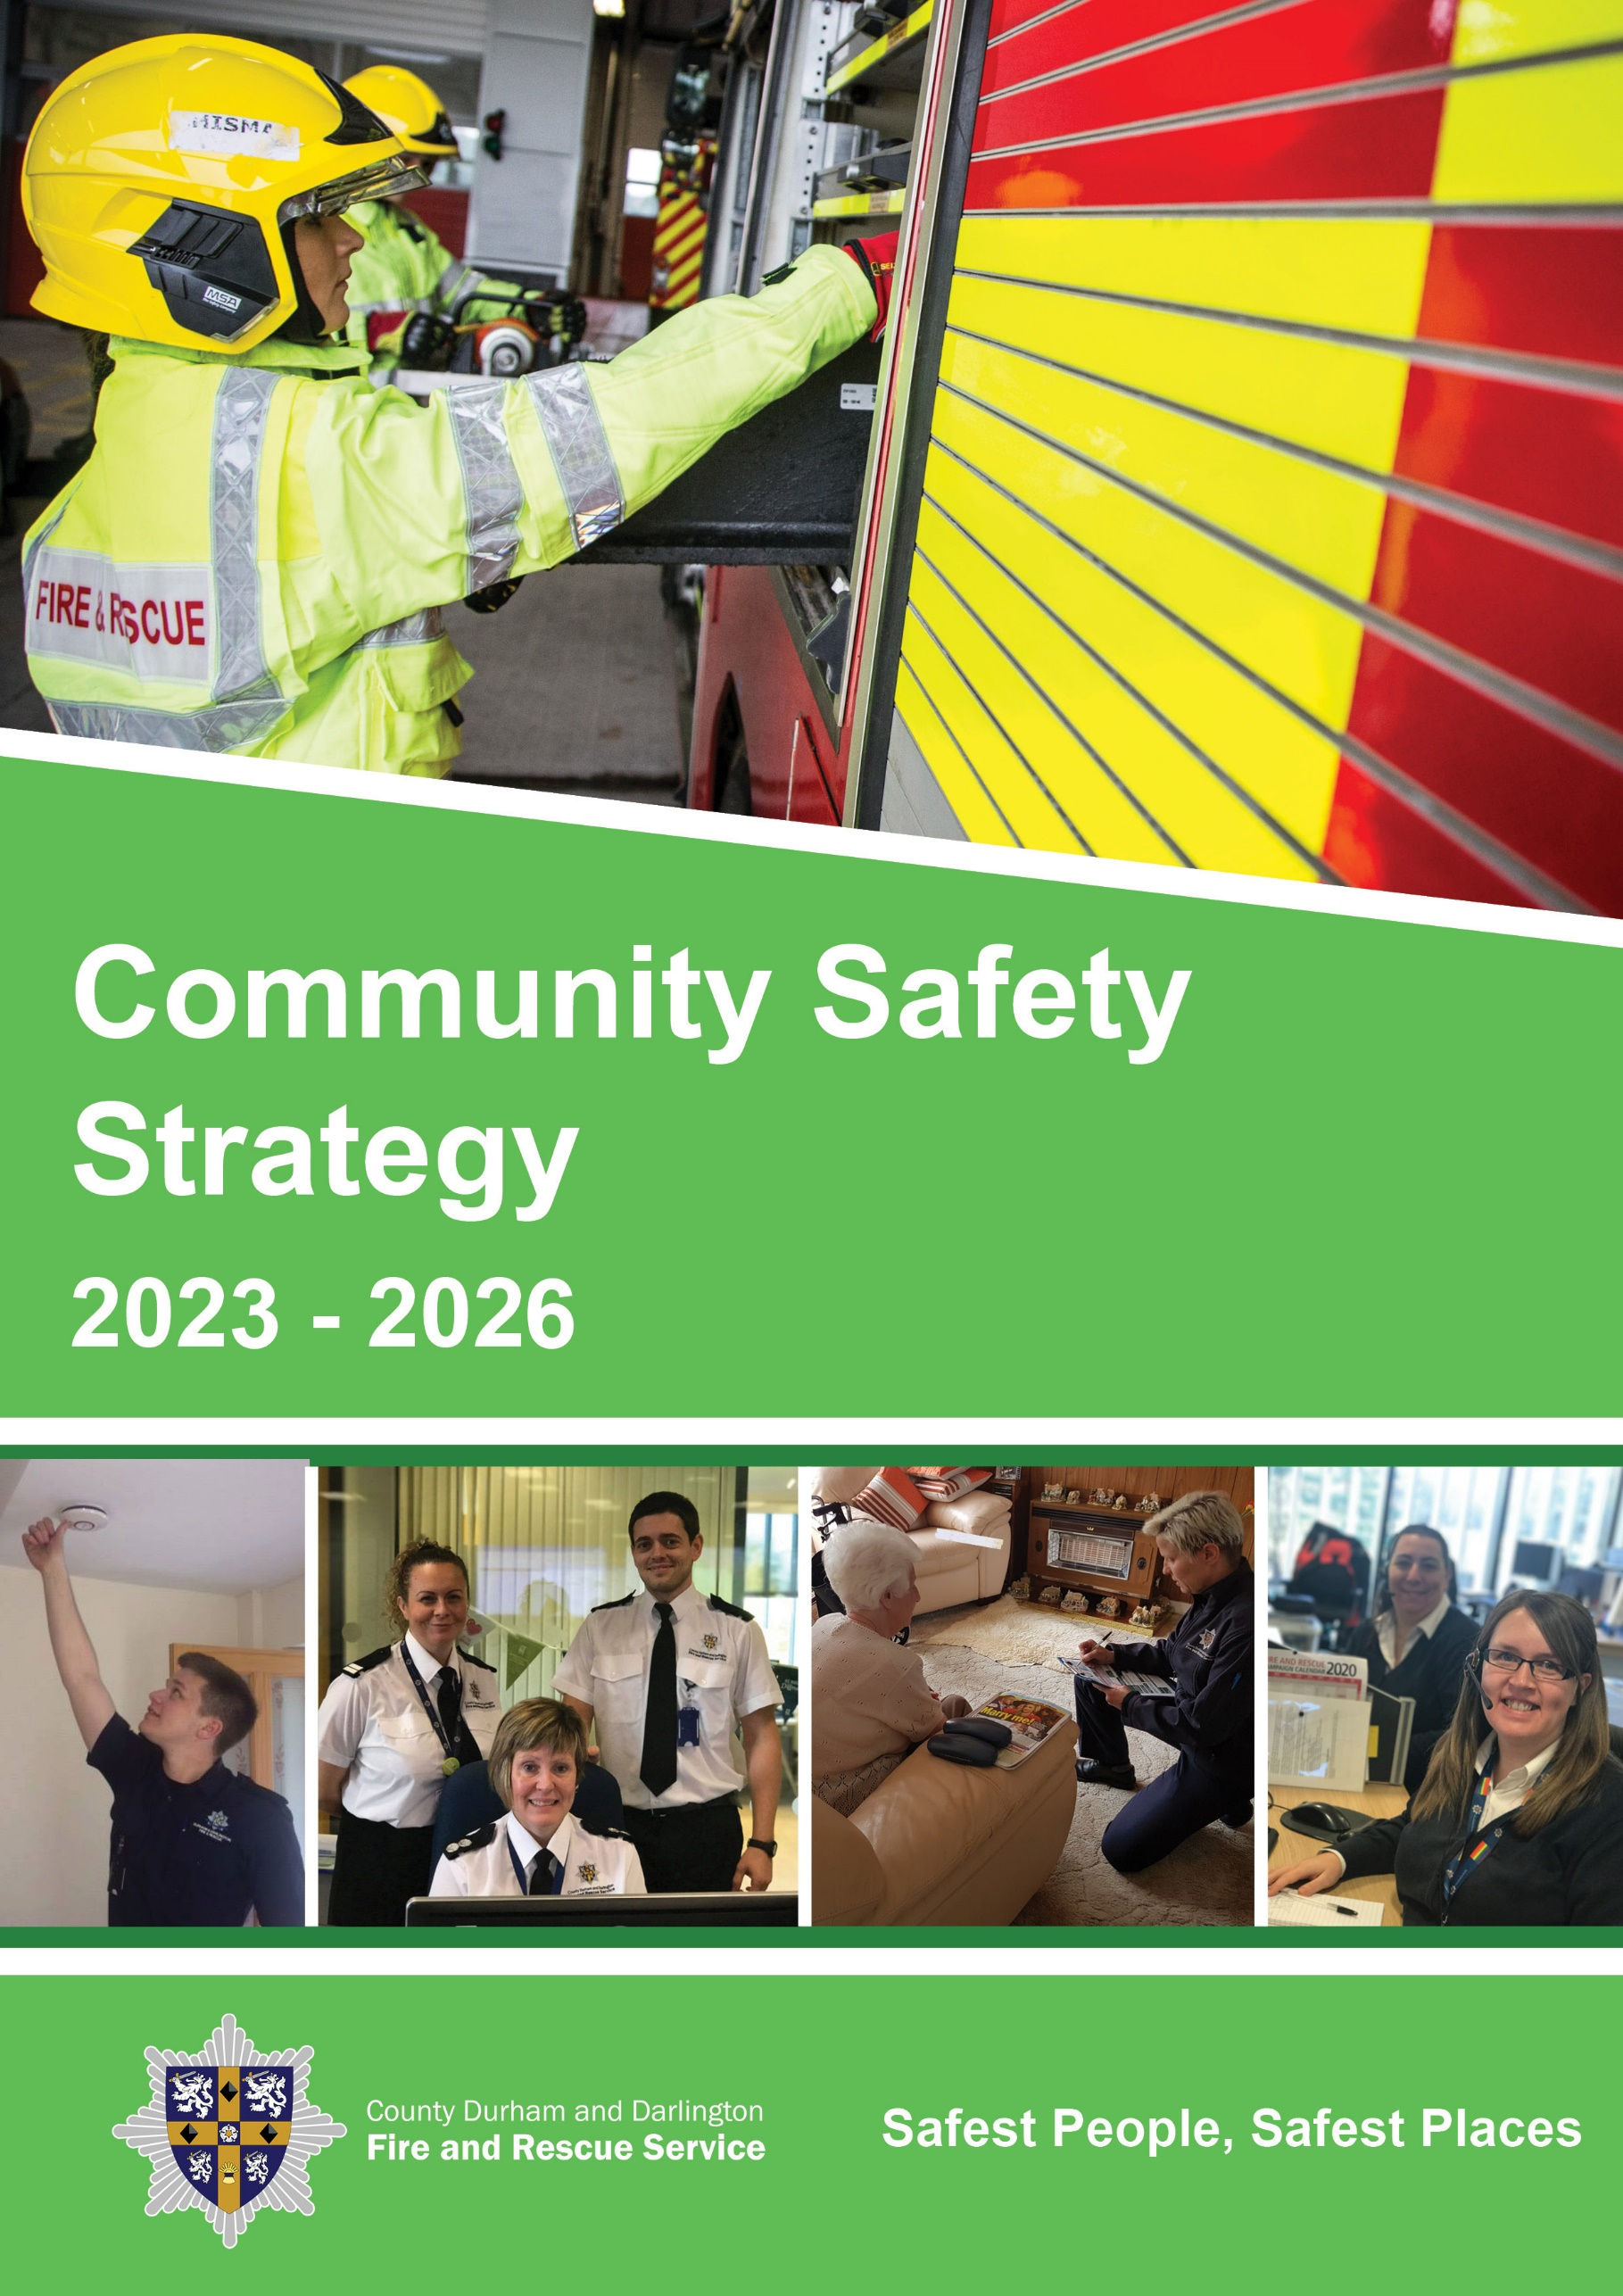

Community Safety and Arson Reduction Strategy 2023-26

Foreword

County Durham and Darlington Fire and Rescue Service (CDDFRS) vision is to have the Safest People, Safest Places. Our core strength in achieving this is through our people who are proud to work for an organisation connected closely with its communities and who are genuinely committed to changing and saving people’s lives.
The Service’s strategic priorities are detailed in our Community Risk Management Plan (CRMP) which explains our vision “Safest People, Safest Places” and how we plan to achieve this. In order to assess all foreseeable fire and rescue-related risks that could affect the communities of County Durham and Darlington we have in place a methodology for assessing the potential of these risks to cause harm to our communities which is set out within our Community Risk Profile (CRP). These risks are then analysed by the Divisional Management Teams to assist them when developing their own station-based profiles.
This Community Safety and Arson Reduction Strategy forms part of a suite of documents which support the delivery of the CRMP. They explain the interventions which will take place to support the achievement of our vision and ensure the Service develops staff with the right professionalism and skills who demonstrate our cultural values, behaviours and ethics. The Strategy covers how we will reduce accidental dwelling fires and their associated injuries, reduce arson and deliberate fires, engage with children and young people, support our decision making with data analysis and business intelligence, and assure us that we are progressing towards our vision of Safest People, Safest Places.
The Government’s fire reform agenda set a clear direction of travel to ensure fire and rescue services are efficient, accountable, transparent and reflective of the diverse communities they serve. This is underpinned by His Majesty’s Inspectorate of Constabulary and Fire and Rescue Services (HMICFRS) regime and the Fire and Rescue National Framework for England that sets out the overall strategic direction for fire and rescue authorities.
We expect the Authority to continue to face a very challenging financial climate going forward with great uncertainty as to future Government funding. This is exacerbated by restrictions on the amount of income we can raise through council tax and predictions of significant pressures on spending. As we look to the future it is important that we do not pause with the delivery of our community safety and arson reduction agenda, we must ensure we continue to identify innovative solutions to engage with our workforce and deliver quality training and supportive measures. The next three years are therefore likely to require further innovation and changes to the way we operate and deliver our services and the Community Safety and Arson Reduction Strategy will help us achieve this.
Ensuring that we have a highly skilled and professional workforce is a key priority for the Service, and our plans include the use of the apprenticeship levy and career progression framework to develop staff. We are seeking to increase diversity in our workforce through a range of innovative methods, as we recognise that we need to have a workforce reflective of our community.
Our commitment to our staff is to maintain a positive organisational culture through continuous improvement. This will ensure that we continue to be successful, despite the challenges ahead. We are committed to delivering a professional, innovative and effective FRS, as we continue to work towards our vision of “Safest People, Safest Places”.

2. Where are we now?

The Service has made good progress in prevention and the efficiency and effectiveness of our prevention services, maintaining the ‘good’ grading for these areas in our latest HMICFRS inspection. A large proportion of our prevention activities are delivered by firefighters with the service’s productivity rates for home fire safety visits much higher than the England average rate.
We received a “good” outcome from the inspection, but an area of improvement identified was a quality assurance process to routinely check the quality of home fire safety visits so the Service can assure itself that staff complete them to a consistent standard.
We have improved our targeting to support vulnerable individuals by adoption of the National Fire Chiefs Council’s (NFCC’s) national risk methodology and have delivered our CRMP commitment that at least 80% of all Home Fire Safety Visits (HFSVs) are targeted towards members of the community who are at the greatest risk from fire. Additionally, we have revisited those residents deemed to be at high risk within a defined period. We have consistently delivered above our annual target of 18,000 Home Fire Safety Visits, except during the 2020/21 Covid period. As a result, compared to five years ago (2017/18) we have achieved a 13% reduction in the number of accidental dwelling fires (ADFs) from 239 to 208, which per 100,000 population is now well below the national average. Over the same period, we have also achieved a 37% reduction in associated injuries from 46 to 29, compared to a national reduction of 24%.
We are aware through national data that there is a greater prevalence of deliberate primary and secondary fires in the North East compared to other parts of England. Deliberate fires in County Durham and Darlington reached an annual peak of 3,898 during the previous Community Safety Strategy. This consisted of 3,393 deliberate secondary and 505 deliberate primary fires which included significant numbers of car fires in some areas. We recognise that weather can impact on the number of outdoor fires, as prolonged periods of hot dry weather, such as in June and August 2022, increased outdoor fires.
During 2022 we combined our Community Safety Team and Arson Reduction Team (CS&ART) into a larger unit with the aim to improve flexibility, efficiency and resilience for the delivery of our prevention work, especially the capacity to tackle deliberate fires and arson.
Investigation of deliberate fires and partnership work with Durham Police indicate a strong correlation from these fires to serious and organised crimes. The introduction of the ISO 17020 fire investigation standard has improved the expertise and competency of our fire investigators.
We have linked with the National NFCC Campaigns to promote home fire safety and wider community safety such as water and road. Our CS&AR team continue to provide educational interventions to children from primary and secondary schools from County Durham and Darlington. The central team have provided a central governance function over the delivery of our five Fire Cadet schemes at stations throughout the Service.
3. Key Drivers

The key drivers which set the direction of the Community Safety and Arson Reduction Strategy are the:

- Reduction of community risk identified in our Community Risk Profile to achieve our vision of Safest People, Safest Places.

- Accountability to provide an effective and efficient fire and rescue service to the communities of County Durham and Darlington.

- Reduction of demand on our resources, in particular arson and deliberate fires due to the high prevalence across the North East and the need to keep resources available for life risk incidents.

- Development of partnerships and collaborations to improve the effectiveness and efficiency of the delivery of our services.

- Compliance with our statutory requirements, national standards and best practice.

- Ensure we continue to build upon Prevention related diagnostics to maintain and improve upon our last report from HMICFRS.

- Working towards compliance with relevant professional Fire Standards for fire and rescue services in England, particularly the Prevention, Safeguarding and Fire Investigation Fire Standards.

- Safeguarding and promoting the welfare of vulnerable adults and young people.

- Fire and Rescue National Framework for England 2018.

4. Our Values, Behaviours and Ethics

Through the professional, innovative and effective delivery of the community safety and arson reduction improvement objectives, we will deliver the outcomes of this strategy and support the achievement of our Community Risk Management Plan.
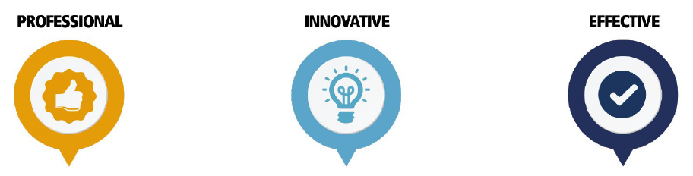
PIE represents our values and describes the service our customers should expect. This element of ‘being the best’ is the external key message around the service we provide

The 4 Cs communicates the behaviours we expect all our people to display at work. Delivery of the 4 Cs across the Service will lead to an organisation which displays the PIE values and fulfils the organisation aim of ‘being the best’.


How We Approach Challenges
Our people should approach challenged with flexibility, enthusiasm, motivation, passion, determination & resilience.

How We Conduct Ourselves
Our people should conduct themselves in an honest, trustworthy, reliable, accountable, consistent and respectful manner.

How We Collaborate
Our people should be approachable, supportive, encouraging, inclusive and show that they value their own development and the development of others when collaborating and working with others.

How We Drive Change Across the Organisation to Make a Difference
Our people should drive change by being creative, resourceful, courageous, original, clear and focused.
Our ethical principles are:

- Putting our communities first – we put the interests of the public, the community, and the service users first.

- Integrity – we act with integrity including being open, honest and consistent in everything we do.

- Dignity and Respect – we treat people with dignity and respect, making decisions objectively based on evidence, without discrimination or bias.

- Leadership – we are all positive role models, always demonstrating flexible and resilient leadership.

- Equality, diversity and inclusion – we continually recognise and promote the value of EDI, both within the FRS and the wider communities in which we serve. We stand against all forms of discrimination, create equal opportunities, promote quality, foster good relations and celebrate difference.

5. Where do we want to be?

There are many areas of good performance throughout our community safety and arson reduction activities, however we aim to continually seek to apply innovative ways of working to improve our effectiveness in reducing risk, driving down the demand on our resources and making our communities safer.
The Community Safety and Arson Reduction Strategy comprises of four main workstreams; home safety, arson and deliberate fires, children and young people and safeguarding. Each year specific actions will be aligned to the workstreams to deliver the goals of the strategy.
Although we have seen a reduction in ADFs, we continue to aim to reduce them further. We will continue to review and seek improvements to our model for HFSVs and risk identification tools. Through working in partnership, we will aim to increase referrals to identify those people at the greatest risk from fire in the home.
In recent years the frequency of deliberate fires and arson throughout some of our communities has increased, resulting in damage to local economies, neighbourhoods and the environment. Due to the high prevalence of deliberate fires, the damage they can cause and the demand on our resources, we must focus more resources on reducing this incident type.
We want to support the development of children and young people by giving them opportunities to learn and develop their life skills. We also recognise the reputation of our service within our communities can improve the engagement with young people who are the hardest to reach and who may resort to anti-social behaviour and criminality. We want to influence children and young adults before they engage in negative behaviours that can impact on the safety of themselves and others.
Safeguarding needs to be based on and reflect the principles of UK legislation aimed at the protection of children and vulnerable adults. In accordance with our legal responsibilities, we need to ensure we have partnership arrangements and data sharing protocols to share information to assist action by other agencies where the safeguarding of the vulnerable person is outside the scope and capabilities of the Service.
The Prevention and Safeguarding Fire Standards detail what professional standards fire and rescue services should meet for Community Safety activities. Complying with the standards will ensure we are working towards ensuring our communities are adopting safer behaviours, improving their safety, health and wellbeing.
Sound community risk planning will reduce community risk, in turn, reducing incidents through the delivery of effective, efficient and targeted prevention activities.
Our culture plays an integral part in enabling us to achieve our vision of Safest People, Safest Places. Through the key objectives set within our Community Safety and Arson Reduction Strategy, we aim to support the creation of a positive, inclusive culture that encourages innovation and continuous improvement. Culture is at the heart of everything that we do, and we understand that the actions we take and the decisions we make through this strategy form part of our cultural journey. We believe achieving the right culture will enable us to give the best services to our communities and be the best fire and rescue service in the UK.

6. Key Principles

To support the delivery of this strategy we have adopted a series of principles that we apply to our improvement objectives. These are:

- We will provide the training and resources that enable our staff to deliver the improvement objectives effectively.

- We will provide local risk-based information and the resources to empower our staff to make intelligence led decisions that reduce community risk.

- We will work with partner agencies to increase referrals for those at the greatest risk from fire to ensure resources are targeted to risk.

- Evaluation of our community safety and arson reduction activities will enable us to understand the impact of our interventions. We will evaluate our activities to ensure we achieve effective outcomes and make improvements where necessary.

- We will introduce recommendations from our staff that improve the delivery of community safety and arson reduction activities and reduce community risk.

To achieve this, the Community Safety and Arson Reduction Strategy has four key improvement objectives (KIO) outlined below. Each objective will have an action plan which will be monitored regularly and refreshed as progress is made.

How do we get there?

We have identified four key improvement objectives to deliver our Community Safety and Arson Reduction Strategy.

Home Safety

We recognise that the effective targeting of resources to reduce community risk is influenced by sound business intelligence and that households may contain individuals who require varying levels of education, intervention and support. We will continue to support the data project of the NFCC Community Risk Programme, which integrates different sources of data into a national database of existing fire and rescue service data to enhance existing datasets. We will also seek to identify additional local datasets that will enhance our identification of vulnerable persons. We will continue to support the research to establish an evidence base of evaluation methodologies to ensure that we use the most consistent, valid, and reliable sector intelligence model available to identify and reduce our community risk.
To maximise the impact of the delivery of our person centred HFSV, we will ensure that our resources are focussed on the individuals and areas of greatest risk. Interaction between staff providing home fire safety advice to members of our communities, will ensure that they support the NHS principle of ‘making every contact count’. We will ensure that our staff who deliver prevention activities are trained to make every contact count and maximise their interactions with our communities. Through partnership engagement we will look to expand our networks through the ‘Eyes Wide Open’ programme to increase direct referrals of vulnerable persons from partners.
We will develop a communications strategy to provide appropriate and accessible information about fire prevention and promote community safety to support the diverse needs of our communities.
The provision of technology creates a platform to deliver more effective home safety advice. We will use technology, supported by business intelligence and the NFCC prevention campaign calendar to provide timely and relevant advice to make people safer in their own homes. The use of technology will also reduce the organisational risk associated with GDPR from the management of large volumes of personal data and improve the precision and relevance of our community risk data.

Arson and deliberate fires

We are committed to the reduction of arson and deliberate fires to create safer homes, safer businesses and buildings, and safer neighbourhoods.
Within our communities, arson and deliberate fires have resulted in the economic loss to individuals, businesses, and local authorities for a significant time. The demand on our resources from arson and deliberate primary and secondary fires outweighs that of other incident types, and results in resources being diverted away from other prevention initiatives.
We will take cognisance of the NFCC Arson Reduction Strategy which outlines a set of operating principles and provides a framework for the continuous development of our approach to arson and deliberate fire reduction. These operating principles enhance collaboration and partnership working and empower local communities to become stronger and more cohesive, to reduce the financial, psychological and environmental impact of arson and deliberate fires.
To reduce the prevalence of arson and deliberate fires, our strategy will be to work in collaboration, partnership and as a stand-alone service, and encourage our partners to use their wider powers under the Crime and Policing Act anti-social behaviour legislation. We will assess the community impact and assist in the development of partnership solutions to reduce the harm of these incidents.
The reduction of arson and deliberate fires to create safer homes, safer businesses and buildings, and safer neighbourhoods will be delivered through partnership initiatives and problem-solving task and finish interventions.
We have introduced a deliberate fire reduction model (Fig. 1) as a framework for our operational crews to use when addressing and reducing deliberate secondary fires. This model enhances our strategic approach by providing a structured process that helps identify the root causes of secondary fires, assess associated risk factors, and implement targeted prevention measures. By utilising this framework, our operational crews can more effectively prioritise resources, tailor interventions to specific concerns, and collaborate with partners when necessary.
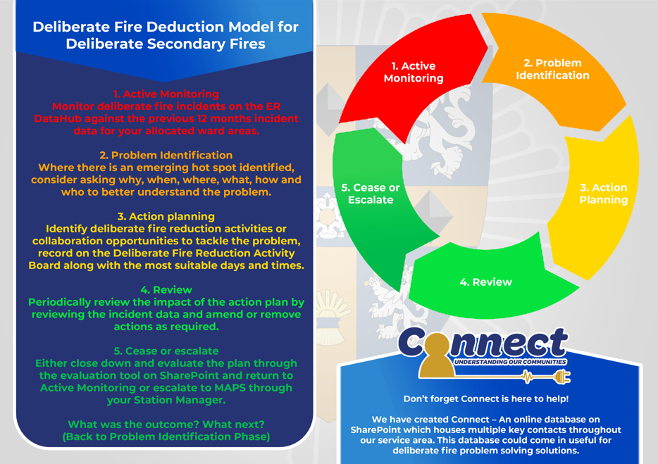Fig. 1 The Deliberate Fire Reduction Model for Deliberate Secondary Fires

Fire Investigation

The NFCC supports fire and rescue service accreditation to the ISO 17020 standard and compliance with the fire investigation competency framework. We are working towards this standard with Durham Constabulary to improve the expertise and competence of our fire investigators. We will always seek to support prosecutions arising from deliberate fire setting and arson related crimes. Our operational crews are cognisant of the need to protect fire scenes for evidential purposes before requesting specialist Fire Investigation advice and support to conduct a full investigation.

Children and young people

We recognise the strong position of being able to influence and provide positive role models for children and young people who may potentially become the perpetrators and victims of arson and deliberate fires, antisocial behaviour and the effect of wider community safety.
We will have a programme of school interventions, providing engagement and education with children and young people so they become aware of the risks they face, understand the consequences of their actions, and can make informed decisions to prevent injuries to themselves, their friends and families, both now and in the future.
Fire cadet schemes have the potential to influence children and young people to maintain a safe and healthy lifestyle, make positive life choices, and provide a potential recruitment pathway to become an on-call, or wholetime firefighter, with the foundation skills and an understanding of the values and behaviours expected from all our members of staff.
We also recognise that engaging with children and young people at an early age through the fire cadet scheme, enables them to lead fulfilling lives, improves their opportunities for employment and supports the Service’s workforce reform programme.
We will build on the introduction of formal qualifications into the cadet schemes by delivering a range of self-improvement programmes for children and young people to give them transferable skills and improve their employment opportunities. These programmes enable children and young people to demonstrate their commitment to the community, improve their fitness and develop their personal interests.
We will encourage the local fundraising for activities that enhance self-improvement programmes and involvement in national activities and provide central funding for essential resources including equipment and uniform. We will provide development opportunities for scheme coordinators to improve their supervision and management of the local schemes and provide a consistent approach to the delivery of scheme objectives.
We will focus our work with the County Durham and Darlington Road Safety Partnership on delivering road safety messages to children and young people through targeted education, however we will also provide general safety advice to all road users and pedestrians to reduce serious injuries our road network.
Working with our local authorities we will promote water safety through the provision of safety equipment at hotspot sites, along with targeted education as part of our school’s educational programme and wider water safety campaign events within communities.
We will design a service campaign schedule to provide delivery tools and clear direction for our Emergency Response crews to prioritise community safety activities for water and road safety at specific times of the year.

Safeguarding

What is safeguarding?
The Government has defined the term 'safeguarding' as:
"The process of protecting children and vulnerable adults from abuse or neglect, preventing impairment of their health and development, and ensuring they are living in circumstances consistent with the provision of safe and effective care that enables them to have optimum life chances."
We are committed to safeguarding of our community to reduce their risk of abuse, harm and neglect.
Safeguarding is everyone's responsibility and all staff who, during the course of their employment, have direct or indirect contact with children and families and vulnerable adults or who have access to information about them, have a responsibility to safeguard and promote the welfare of children and vulnerable adults.
There is a duty on organisations to make appropriate arrangements to safeguard and promote the welfare of children and vulnerable adults. Also, government guidance makes it clear that it is a shared responsibility and depends upon effective joint working between agencies and professionals that have different roles and expertise.
We are committed to protecting and supporting vulnerable people including children, young people or adults. We will provide safeguarding training to ensure that our staff understand how to identify forms of abuse and take action to safeguard vulnerable people.
The Service not only recognises, and responds to, the risk from fire, road traffic collisions and other life-threatening scenarios but across a broader range of themes associated with those who may be at risk from harm.
The Director of Community Risk Management is the strategic champion for safeguarding, and we have designated safeguarding responsible persons comprising of the Group Managers and Community Safety staff. The designated person will ensure that procedures are followed when a safeguarding matter is raised.
The Service recognises the significant role it can play in partnership with other agencies and works with the adult and children’s' safeguarding boards for County Durham and Darlington.
The Service will support people by offering the following services:
- Offer and complete home fire safety visits to reduce the risk from fire and identify other sources of vulnerability for referral to partner agencies;
- Work with other agencies to support the victims of domestic abuse;
- Offer advice on arson prevention;
- Liaise with Police wherever a hate-crime is suspected of being committed, or information is received that a hate-crime may be about to be committed.

8. Governance and Measuring Progress

We will monitor progress of this strategy in the following ways:

Role of the Fire Authority and Service Leadership Team (SLT)
Both Members of the Fire Authority and SLT believe in this strategy and that it will help to deliver the Service’s vision in respect of its people. Leading by example, our Members and SLT will set the standard for what is expected of all staff in enabling this strategy to be delivered by 2026.

Role of our Staff
This strategy will only be successful if all staff within CDDFRS support it, making the vision of what the Service will look like from a community safety and arson reduction perspective, a reality. In supporting this strategy, employees will not only assist in enabling the actions outlined but they will also demonstrate their support through their behaviours.

Key Performance Indicators (KPI’s)
We have a suite of appropriate Key Performance Indicators to help measure the progress of this strategy.

Staff Survey
Our staff survey will assist us in having insight into the motivations, attitudes and behaviours of our staff. Progress will be measured against key indicators and shared with the workforce.

Reporting Progress
Scrutiny of progress against the strategy will be undertaken by the Performance Board (PB) who will receive regular reports from the Director of Community Risk Management, in their role as strategic lead for community safety and arson reduction.

Measuring Perceptions/ Sense Checking
We will regularly ask for feedback from our staff to inform us of our progress on elements with the Community Safety and Arson Reduction Strategy through our engagement sessions, range of leadership forums and through meetings with our representative bodies. Their opinions and suggestions will be used to influence improvement.

Keeping it current
We will provide a progress report to the relevant committees and update the action plan annually to ensure it remains current.

